Average spending in malls

The study demonstrates spending patterns of females and males from different age groups. The data fetched from a mall from past year of the sales were recorded for their gender, average spending, spending score and their age. The data demonstrates that a female spends more of their earnings at the mall though having less average salary from the men.

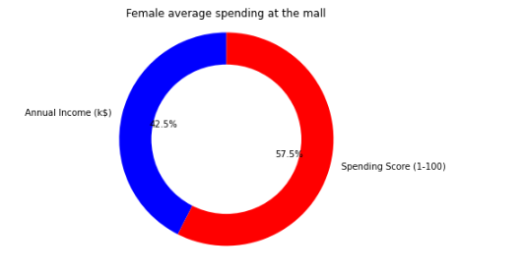 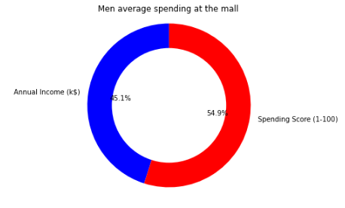

The data above compares the annual income of females versus their spending score in the left and the same for men on the right. The data demonstrates that the mean income of females as who visited the mall was 42.5% while their spending score was recorded to be 57.5%. On the other hand, the males mean average income was 45.1% who spent 54.9% in the malls.

On a cumulative averaging of the collected data it was revealed that a very few number of men and women having a higher salary went to shopping and vice versa was noticed for the men and women having a annual income on the lower and average side.

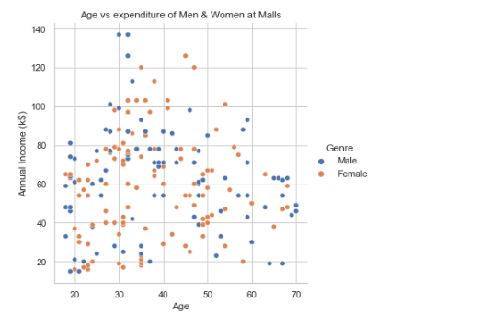

The data also revealed that teenagers did not went for shopping at the mall while the people from the age group 20 to 60 visited the mall for a purchase frequently as it can be noticed from the below graph

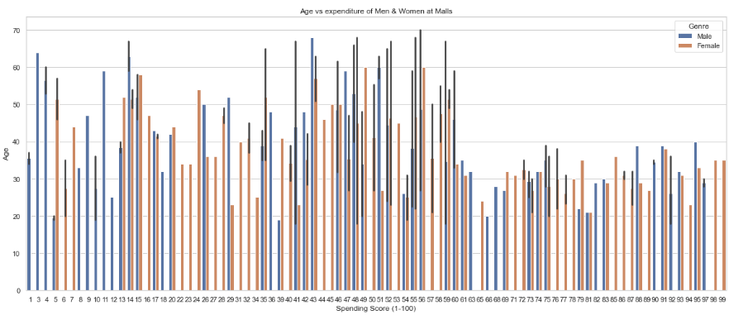

On inquiring the average expenditure versus the annual income of the people having a moderate salary range liked to purchase from the mall more frequently than people having their salary on a higher or lower side. However, for those people having more salary also liked spending more of their income in the malls

